Architecture Design Report

Submitted partial fulfilment for the Course of

CSA1012 Software Engineering
to receive the award of the degree of

ARTIFICIAL INTELLIGENCE AND MACHINE LEARNING

Submitted by

Ramana Y (192525476)

Under the Supervision of ANITADAVAMANI K



SIMATS ENGINEERING
Saveetha Institute of Medical and Technical Sciences Chennai-602105

Architecture Design Report

1. System Requirement Analysis

1.1. System Objectives
The primary objectives of the FoodRescue Connect system are derived directly from the problem statement:

- Develop an intelligent platform for food donation and redistribution management.
- Connect restaurants, supermarkets, NGOs, volunteers, and beneficiaries through a centralized system.
- Monitor food availability, quantity, expiry time, and quality in real time.
- Apply AI algorithms to optimize food allocation and transportation routes.
- Generate real-time notifications for available food donations and pickup requests.
- Track food collection, delivery status, and beneficiary distribution.
- Produce analytical reports on food waste reduction and donation activities.
- Promote sustainable food recovery and community welfare through digital technology.

1.2. Functional Requirements
Based on the problem statement and objectives, the following functional requirements are identified:

- User Registration and Profile Management: Allow different user roles (donors, NGOs, volunteers, beneficiaries) to register, create profiles, and manage their information.
- Food Donation Listing: Donors can list available surplus food, including type, quantity, expiry date, and pickup location.
- Food Request Management: Beneficiary organizations can view available food donations and place requests.
- Real-time Food Monitoring: The system should monitor food availability, quantity, expiry time, and quality (e.g., through IoT sensors for temperature/humidity).
- AI-driven Allocation and Route Optimization: Implement AI algorithms to match donations with requests, optimize transportation routes for volunteers, and prioritize urgent requests.
- Notification System: Generate real-time notifications for new donations, pickup requests, route changes, and delivery status updates.
- Tracking and Tracing: Provide real-time tracking of food collection, transit, and delivery status.
- Reporting and Analytics: Generate reports on food waste reduction, donation volumes, distribution efficiency, and environmental impact.
- Search and Filtering: Allow users to search and filter food donations or requests based on various criteria (e.g., location, food type, quantity).
- Communication Module: Facilitate communication between donors, volunteers, and NGOs.

1.3. Non-Functional Requirements
Key non-functional requirements influencing the architecture include:

- Scalability: The system must be able to handle a growing number of users (donors, NGOs, volunteers, beneficiaries), increasing data volumes (food listings, tracking data), and a rising number of transactions (donations, pickups, deliveries) without significant performance degradation.
- Performance: The system should provide quick response times for critical operations such as searching for donations, optimizing routes, and sending real-time notifications. AI algorithms for route optimization and allocation should execute efficiently.
- Reliability: The system must be consistently available and perform its functions correctly. Data integrity for food listings, tracking, and user information is crucial.
- Availability: The platform should be highly available, ideally 24/7, to ensure continuous operation for critical activities like real-time tracking and urgent donation requests.
- Security: User data, donation information, and location data must be protected. The system should implement robust authentication, authorization, and data encryption mechanisms to prevent unauthorized access and data breaches.
- Maintainability: The system's codebase should be modular, well-documented, and easy to update, debug, and extend with new features or AI models.
- Usability: The user interface for all stakeholders (donors, NGOs, volunteers, beneficiaries) should be intuitive and easy to use.
- Interoperability: Potential for integration with external systems such as mapping services (for GPS), IoT platforms (for food quality monitoring), and existing NGO management systems.
Kanban worflow
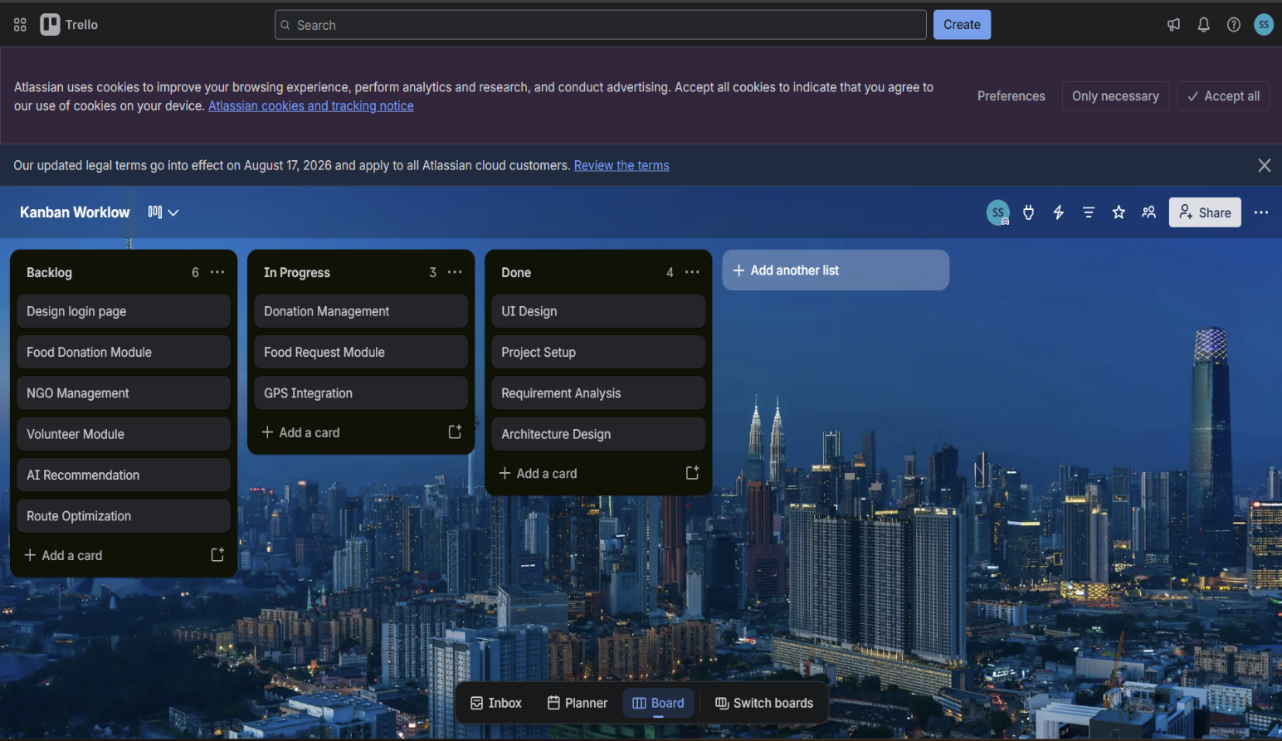

2. Selection of Software Architecture
Given the requirements for scalability, real-time processing, AI integration, and diverse user roles, a Microservices Architecture combined with Event-Driven Architecture is the most suitable choice for FoodRescue Connect.

2.1. Justification for Microservices Architecture
- Scalability: Microservices allow individual services to be scaled independently based on demand. For instance, the AI optimization service or the notification service can be scaled up during peak hours without affecting other parts of the system. This is crucial for handling fluctuating loads from various users and real-time data streams [1].
- Resilience: The failure of one service does not necessarily bring down the entire system. This isolation enhances the overall reliability and availability of FoodRescue Connect.
- Technology Heterogeneity: Different services can be developed using different programming languages, databases, and technologies best suited for their specific function. For example, a Python-based service might handle AI/ML models, while a Node.js service manages real-time notifications.
- Ease of Development and Deployment: Smaller, independent teams can work on different services concurrently, accelerating development cycles. Services can be deployed independently, reducing the risk associated with large, monolithic deployments.
- Maintainability: Each service is smaller and has a focused responsibility, making the codebase easier to understand, maintain, and refactor.

2.2. Justification for Event-Driven Architecture (EDA)
- Real-time Processing: EDA is ideal for handling real-time events such as new food donations, pickup requests, or changes in delivery status. Services can react immediately to these events, enabling real-time tracking and notifications [2].
- Decoupling: Services communicate asynchronously through events, reducing direct dependencies between them. This improves flexibility and allows services to evolve independently.
- Scalability: Event brokers (like Kafka or RabbitMQ) can handle high volumes of events, allowing the system to scale effectively with increasing data streams from IoT devices or user interactions.
- Extensibility: New services can be easily added to subscribe to existing events or publish new ones, facilitating future enhancements (e.g., integrating with new types of donors or IoT devices).

2.3. Hybrid Approach
The combination of Microservices and Event-Driven Architecture provides a robust and flexible foundation. While microservices define the structural decomposition of the system into independent, deployable units, the event-driven paradigm dictates how these services communicate and react to changes, particularly for real-time and asynchronous operations. This hybrid approach addresses the complex requirements of FoodRescue Connect, especially those related to real-time monitoring, AI optimization, and diverse stakeholder interactions.

Raptor Programming
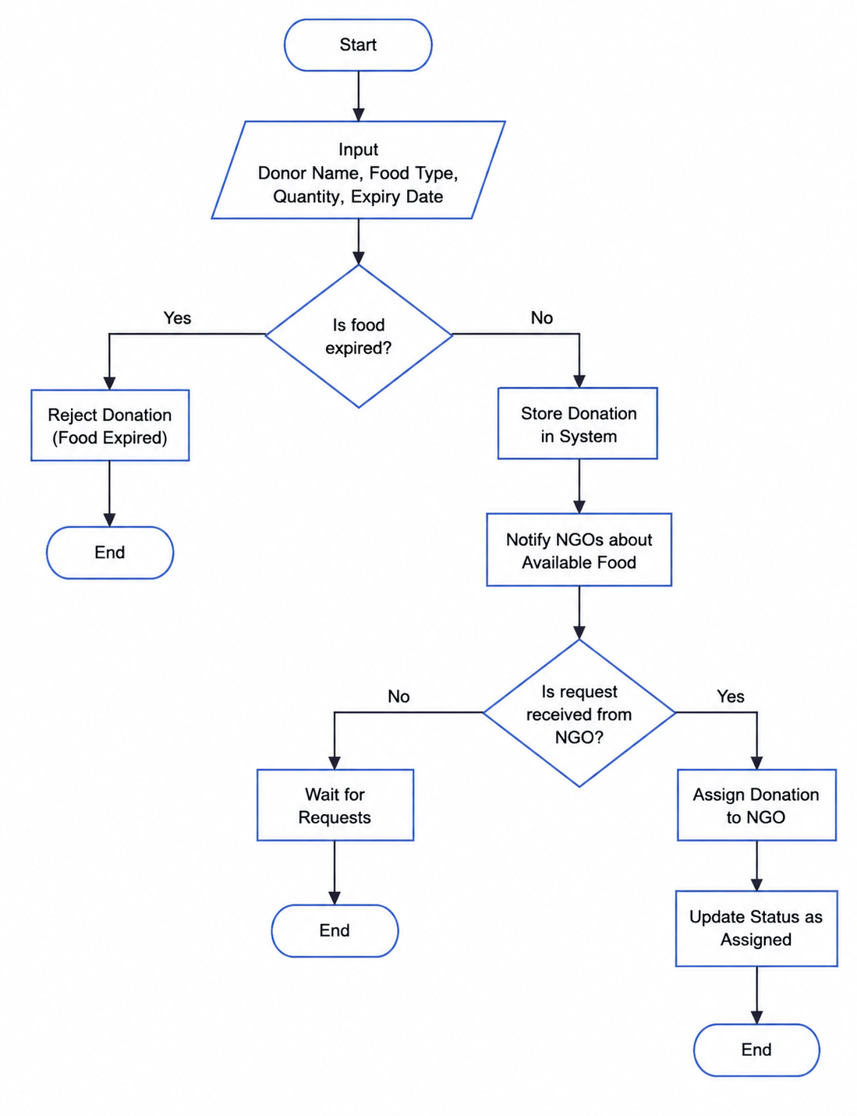

Jira Workflow

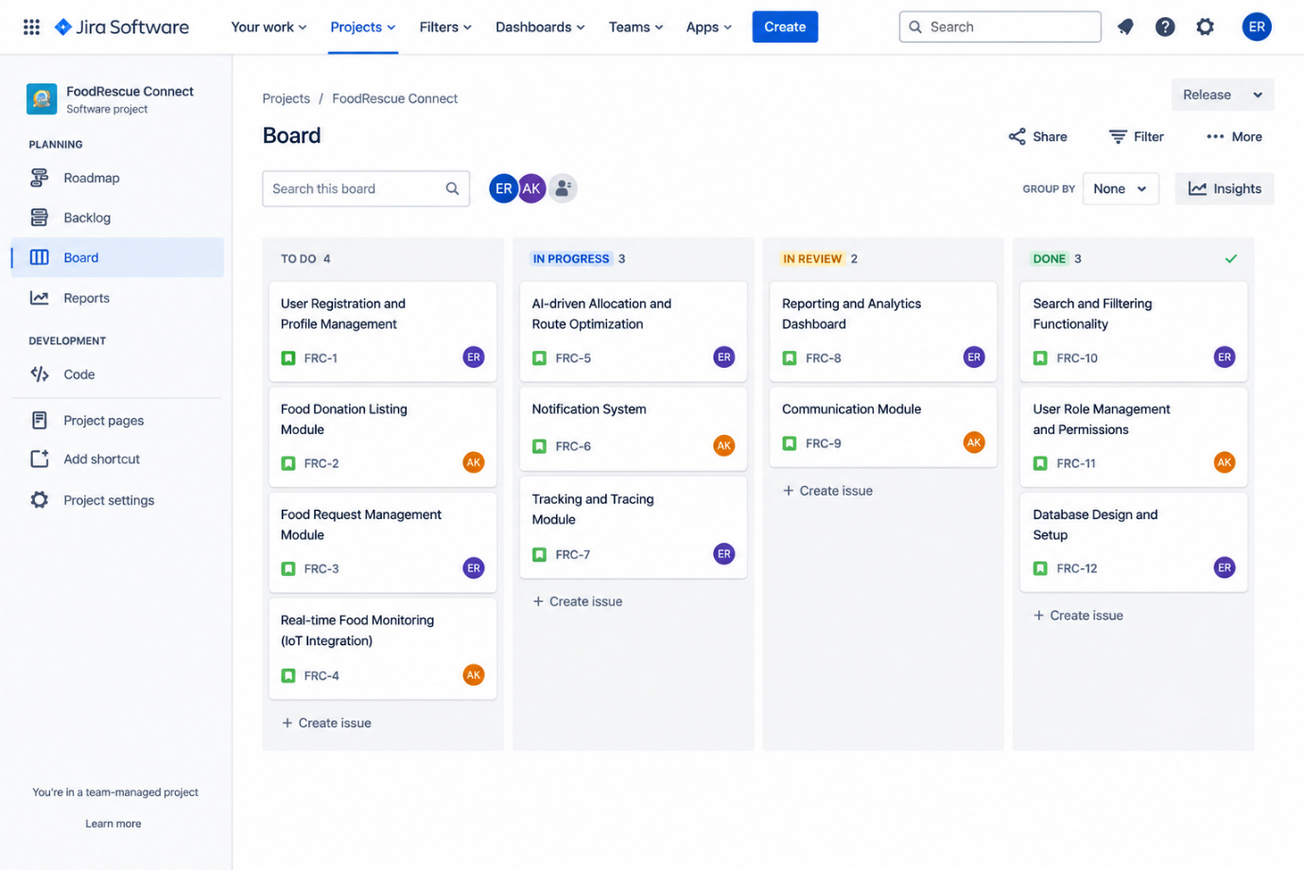

3. Architecture Diagram and Component Design
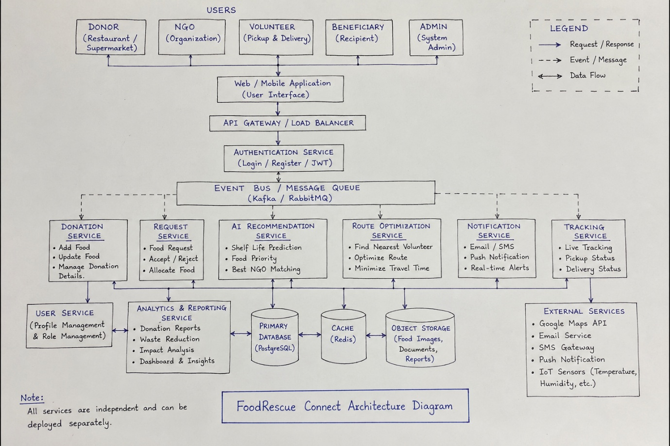
Below is the high-level architecture diagram for the FoodRescue Connect system, illustrating the key components and their interactions.

4. Explain Components and Their Interactions

Overview of Components

The FoodRescue Connect platform is built as a set of independent microservices that collaborate to handle food donation and redistribution. Each component has a specific role, and they communicate through both synchronous REST APIs and asynchronous event-driven messaging. Below is a description of each architectural component, followed by how they exchange data and the typical end-to-end workflow.

4.1. Description and Responsibilities of Each Architectural Component
User Management Service: Manages user registration, authentication, authorization, and profile information for all user roles (donors, NGOs, volunteers, beneficiaries).
Overview of Components
The FoodRescue Connect platform is built as a set of independent microservices that collaborate to handle food donation and redistribution. Each component has a specific role, and they communicate through both synchronous REST APIs and asynchronous event-driven messaging. Below is a description of each architectural component, followed by how they exchange data and the typical end-to-end workflow.

1. Component Descriptions and Responsibilities
Web / Mobile Application (User Interface)
This is the front-end layer that users interact with. It provides role-specific dashboards: donors can list food, NGOs can request and accept donations, volunteers see assigned tasks with navigation, beneficiaries browse available food, and admins monitor the system. The UI consumes REST APIs and uses WebSockets for real-time updates.
API Gateway / Load Balancer
The single entry point for all client requests. It handles routing, load balancing, authentication token validation, rate limiting, and request logging. It protects backend services by filtering malicious traffic and caches frequent responses to improve performance.
Authentication Service
Manages user identity and access. It handles registration, login, JWT generation and validation, role-based permissions (donor, NGO, volunteer, beneficiary, admin), password reset, and session management. Every request that reaches the API Gateway is validated against this service.
Event Bus / Message Queue (Kafka / RabbitMQ)
The central nervous system for asynchronous communication. Services publish events (e.g., Donation.Created, Allocation.Accepted, Tracking.PickedUp) to specific topics, and other services subscribe to those topics to react without direct coupling. This enables reliable, ordered, and replayable event delivery.
Donation Service
Owns the lifecycle of food donations. It allows creation, updating, and deletion of listings, storing details like food type, quantity, expiry date, quality status, and location. It also manages donation images (stored in object storage) and updates statuses (Open → Assigned → Picked → Delivered). It publishes events whenever a donation changes state.
Request Service
Handles food requests from NGOs. It creates requests, matches them against available donations (often using AI recommendations), and manages acceptance or rejection of suggested allocations. It coordinates the allocation process and ensures that each donation is assigned to the most appropriate NGO.
AI Recommendation Service
Provides intelligent decision support through machine learning models:
- Shelf Life Prediction – estimates remaining usability based on food type and storage conditions.
- Food Priority Scoring – assigns urgency scores to donations to avoid spoilage.
- NGO Matching – suggests the best NGO for each donation by considering proximity, capacity, past performance, and beneficiary needs.
These predictions are exposed via REST APIs and are also triggered automatically when new donations arrive.
Route Optimization Service
Optimises logistics for volunteers. It finds the nearest available volunteer, calculates the shortest or fastest route using Google Maps API, and generates a detailed plan with turn-by-turn directions. It also recalculates routes if changes occur (e.g., volunteer cancellation). The service assigns volunteers and publishes route-related events.
Notification Service
Manages all communications: emails, SMS, push notifications, and in-app alerts. It uses templates to send timely messages—for example, notifying NGOs about new donations, reminding volunteers of pickups, or updating donors on delivery status. It respects user preferences and tracks delivery success.
Tracking Service
Provides real-time visibility during collection and delivery. Volunteers update their GPS location and status (pickup, in-transit, delivered) through the mobile app. This service logs all movements, calculates ETAs, and publishes tracking events so that donors and NGOs can follow the progress on a live map.
User Service
Maintains user profiles, roles, preferences, and contact details. It also manages volunteer availability schedules and organisation profiles. This service is consulted by other components (like Route Optimisation) to determine who is available for a task.
Analytics & Reporting Service
Aggregates data from all services to generate insights. It produces dashboards on food rescued, waste reduction, CO₂ savings, volunteer hours, and beneficiary reach. It creates periodic reports (daily, weekly, monthly) and feeds performance data back into AI models to improve future recommendations.
Primary Database (PostgreSQL)
Relational database that stores structured data: user accounts, donation records, allocation transactions, audit logs, and report summaries. It ensures ACID compliance for critical operations.
Cache (Redis)
In-memory cache used for session storage, frequently accessed data (popular donations, user profiles), API response caching, and temporary workflow state. This reduces database load and improves response times.
Object Storage
Stores unstructured files: food images, quality certificates, generated reports (PDF, CSV), and user profile pictures. It is accessed directly by services via pre-signed URLs.
External Services
- Google Maps API – for routing, geocoding, and distance calculations.
- Email Service – SendGrid or AWS SES for reliable email delivery.
- SMS Gateway – Twilio for urgent SMS alerts.
- Push Notification Service – Firebase Cloud Messaging for mobile app notifications.
- IoT Sensors – optional temperature/humidity sensors for food quality monitoring (integrated via the Tracking Service).

2. Communication and Data Exchange
Components interact through three main patterns:
- Synchronous REST APIs – used for immediate actions like user authentication, CRUD operations on donations, and route calculations. The API Gateway routes these calls to the appropriate service, which may in turn call other services (e.g., Route Optimisation calling Google Maps and User Service).
- Asynchronous Event-Driven Messaging – for operations that do not require immediate response. When a donation is created, the Donation Service publishes an event to the Event Bus. The AI Recommendation Service, Notification Service, and Analytics Service all subscribe to this event and act independently. This decouples producers from consumers, enhances resilience, and allows services to scale separately.
- Database and Cache Access – each service owns its data store; they do not share databases directly. Instead, they read/write to their own tables in PostgreSQL or MongoDB, use Redis for temporary data, and store files in object storage. Cross-service data sharing happens via events or through dedicated APIs (e.g., User Service exposes volunteer availability to Route Optimisation).
The Event Bus is central to the system’s flexibility. Key event topics include:
- donation.events – for creation, update, allocation, completion.
- request.events – for request creation and acceptance.
- route.events – for route assignment and updates.
- tracking.events – for pickup, transit, and delivery status changes.
- notification.events – for tracking sent messages and delivery status.
- user.events – for profile changes and role updates.
All services emit events and consume relevant topics, ensuring that the system remains loosely coupled while maintaining a consistent view of the overall process.

3. Overall System Workflow – A Step-by-Step Walkthrough
Phase 1 – Donation Creation
A donor (restaurant or supermarket) logs in via the mobile/web app. After authentication, they fill in details about surplus food (type, quantity, expiry date, quality, pickup location) and upload photos. The Donation Service validates the input, stores the record in PostgreSQL, uploads images to object storage, and publishes a Donation.Created event to the Event Bus. The donor receives a confirmation immediately.
Phase 2 – Intelligent Processing
The Event Bus delivers the Donation.Created event to three subscribers:
- AI Recommendation Service – predicts shelf life, calculates a priority score, and runs its matching algorithm to propose the best NGO. It stores these recommendations in Redis for quick retrieval.
- Notification Service – immediately sends SMS and push alerts to nearby NGOs and volunteers about the new donation.
- Analytics Service – logs the donation for metrics (total food volume, frequency, etc.).
Once the AI finishes matching, it publishes an AI.MatchFound event containing the proposed allocation.

Phase 3 – Request and Allocation
The Request Service consumes the AI.MatchFound event and creates an allocation suggestion. It sends this suggestion to the recommended NGO via a push notification (handled by the Notification Service). The NGO staff reviews the suggestion in their app and either accepts or rejects it. If accepted, the Request Service updates the allocation status and publishes an Allocation.Accepted event. This event triggers the Donation Service to change the donation status to “Assigned” and the Notification Service to inform the donor that their food will be picked up.
Phase 4 – Logistics and Volunteer Assignment
The Route Optimisation Service subscribes to Allocation.Accepted. It queries the User Service for available volunteers near the donor’s location and the NGO’s destination. It then calls Google Maps API to compute the optimal route, considering real-time traffic. The service selects the most suitable volunteer, generates a route plan with ETA, and publishes a Route.Assigned event. The Volunteer Service updates the volunteer’s task list, and the Notification Service sends a detailed task alert to the volunteer (including directions and pickup time).
Phase 5 – Pickup and Delivery Execution
The volunteer navigates to the pickup location using the provided route. Upon arrival, they scan a QR code on the donation packaging via the mobile app. The Tracking Service receives this scan, updates the status to “Picked Up”, and publishes a Tracking.PickedUp event. This event causes:
- Notification Service to inform the donor and NGO that pickup is complete.
- Donation Service to mark the status as “In Transit”.
- Analytics Service to record the pickup time.
The volunteer then drives to the NGO, with live GPS updates feeding into the Tracking Service. When they arrive, they scan another QR code for delivery. The Tracking.Delivered event is published, triggering similar updates: the donation status becomes “Completed”, and all relevant parties receive confirmation.
Phase 6 – Completion and Analytics
All events generated throughout the process are consumed by the Analytics & Reporting Service. It continuously aggregates data to update real-time dashboards and produce impact metrics: total food rescued (kg), CO₂ emissions saved, number of meals provided, volunteer hours contributed, and active users. At regular intervals, it generates comprehensive reports that are sent via email to stakeholders and also published on a public dashboard.

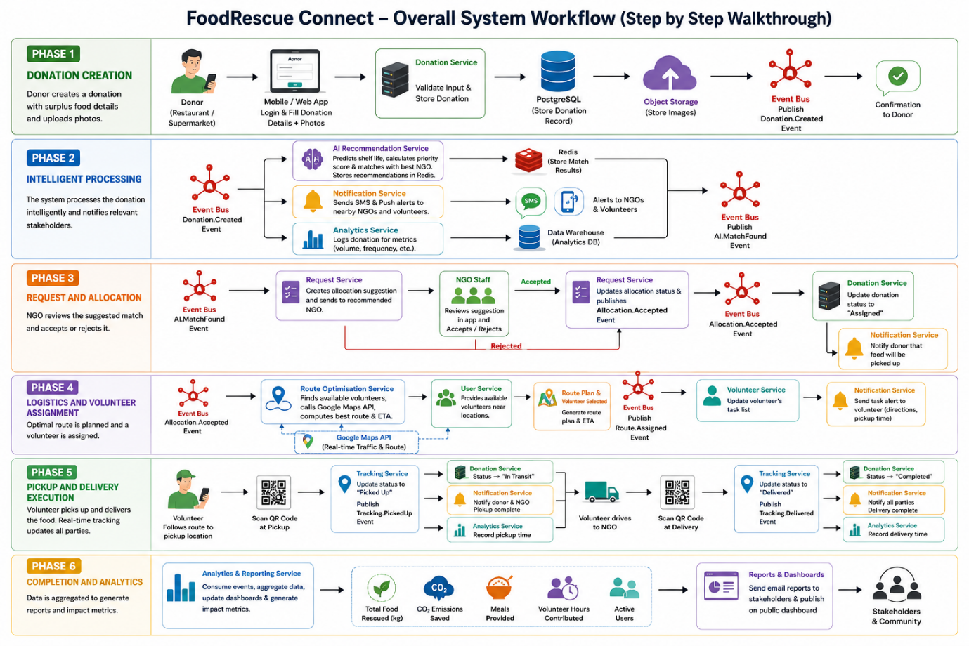

5. Discuss Quality Attributes

5.1. Evaluation of Proposed Architecture Against Quality Attributes
Scalability:
- Microservices: The architecture supports horizontal scaling of individual services. Services experiencing high load (e.g., Notification Service, AI Optimization Service) can be scaled independently by deploying more instances without affecting other services. This is crucial for handling a growing user base and increasing data volumes from real-time tracking and IoT devices [1].
- Event-Driven Architecture: The asynchronous nature of EDA and the use of an Event Broker allow for high throughput and decoupling, enabling services to process events at their own pace and scale independently. This prevents bottlenecks and ensures the system can handle bursts of activity.

Security:
- API Gateway: Provides a centralized point for authentication and authorization, enforcing security policies before requests reach individual microservices. This simplifies security management and reduces the attack surface.
- Microservices: Allows for fine-grained security controls at the service level. Each service can have its own security context and access policies. Data encryption (in transit and at rest) will be implemented across all components.
- Data Stores: Access to data stores will be restricted to specific services, adhering to the principle of least privilege.

Performance:
- Microservices: Enables optimization of individual services for performance. High-performance services (e.g., AI algorithms) can be built with technologies best suited for speed. Caching mechanisms can be implemented at the API Gateway or within services to reduce latency.
- Event-Driven Architecture: Asynchronous processing prevents blocking operations, ensuring that the system remains responsive even under heavy load. Real-time notifications and tracking benefit from this immediate event processing.

Reliability:
- Microservices: Service isolation means that the failure of one service does not cascade to others, enhancing overall system reliability. Mechanisms like circuit breakers, retries, and bulkheads can be implemented to improve fault tolerance.
- Event Broker: Provides message persistence and guaranteed delivery, ensuring that events are not lost even if a consuming service is temporarily unavailable.

Maintainability:
- Microservices: Smaller, independent codebases for each service are easier to understand, test, debug, and deploy. This reduces the complexity of maintenance and allows for faster iterations and updates.
- Clear Boundaries: Well-defined service boundaries and APIs promote modularity and reduce inter-service dependencies, making it easier to evolve the system over time.

Availability:
- Microservices: Services can be deployed in a highly available manner (e.g., across multiple availability zones) with load balancing. If one instance fails, others can take over.
- Event Broker: High-availability configurations for the Event Broker ensure that the central communication backbone remains operational.

6. Justify Architectural Decisions

6.1. Rationale Behind Architectural Choices
The decision to adopt a Microservices Architecture coupled with an Event-Driven Architecture for FoodRescue Connect is driven by the need to build a system that is:

- Highly Scalable: The platform is expected to grow significantly in terms of users, donations, and geographical coverage. Microservices allow for independent scaling of components, while EDA handles high throughput of real-time data.
- Resilient and Reliable: Food redistribution is a critical operation where delays or failures can lead to food spoilage. The fault isolation of microservices and the guaranteed delivery of events in EDA ensure high reliability and continuous operation.
- Agile and Adaptable: The domain of food donation and redistribution may evolve, requiring new features, integrations (e.g., new IoT devices, different mapping services), or changes to AI models. The modularity of microservices and the extensibility of EDA facilitate rapid development and deployment of changes without impacting the entire system.
- Optimized for Real-time Operations: Real-time monitoring of food, route optimization, and instant notifications are core requirements. EDA is inherently suited for processing and reacting to events in real-time.
- Leveraging AI Effectively: AI components (route optimization, food allocation) can be developed and deployed as independent microservices, allowing for specialized technology stacks (e.g., Python for ML) and independent updates without affecting the rest of the system.

6.2. Trade-offs Considered
While offering significant advantages, this architectural approach also involves certain trade-offs:

- Increased Complexity: Managing a microservices architecture is inherently more complex than a monolithic application. It requires robust infrastructure for service discovery, configuration management, distributed tracing, logging, and monitoring. The Event-Driven nature adds another layer of complexity in understanding data flow and debugging [3].
- Operational Overhead: Deploying and managing multiple services requires more operational effort and potentially specialized DevOps skills. This includes managing container orchestration (e.g., Kubernetes), CI/CD pipelines for each service, and distributed monitoring tools.
- Data Consistency Challenges: Ensuring data consistency across multiple services in a distributed system can be challenging. The
eventual consistency model often used in EDA requires careful design to handle potential inconsistencies temporarily.
- Inter-service Communication Overhead: While asynchronous communication reduces coupling, there is an overhead associated with message serialization, deserialization, and network latency between services.

6.3. How the Chosen Architecture Supports Future Enhancements, System Integration, and Long-Term Maintainability
- Future Enhancements: The modular nature of microservices allows for easy addition of new features as independent services. For example, integrating blockchain for transparent food tracking or adding advanced predictive analytics for food demand can be done by developing new services that interact with the existing event stream.
- System Integration: The API Gateway provides a standardized interface for external systems to integrate with FoodRescue Connect. The Event-Driven Architecture facilitates integration with diverse external platforms (e.g., new IoT devices, different mapping providers, third-party logistics services) by simply subscribing to or publishing relevant events.
- Long-Term Maintainability: The small, focused nature of microservices makes them easier to maintain and update. Teams can independently evolve services without affecting the entire system. This reduces technical debt and ensures the platform can adapt to changing requirements and technologies over its lifespan.

